Tool Guide – Arpaname

Introduction
Arpaname is a lightweight reconnaissance utility that allows you to use an IP address to lookup its corresponding reverse DNS lookup domain. Arpaname translate UP addresses to the corresponding ARPA names, such as IN-ADDR.ARPA or IP6.ARPA names. When using Arpaname for 8.8.8.8, you will most likely get the response “8.8.8.8.IN-ADDR.ARPA”.
Safety Disclaimer: Use only on networks and systems for which you have explicit authorisation. Unauthorized use of tools can be Illegal, unethical and harmful.

Setup and Launch
  - Step1: Open Deakin Detonator Toolkit
- Open a terminal in your Kali Linux environment.
- Navigate to the toolkit directory:
cd Deakin-Detonator-Toolkit
- Start the application:
yarn run tauri dev
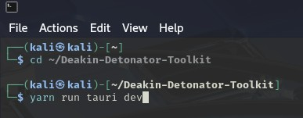
Once launched, the graphical user interface will open on the About page.

  - Step2: Find Tool-example
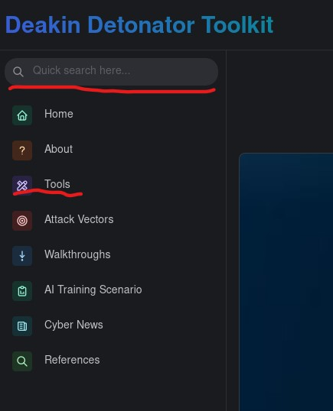
Click Tools in the left-hand navigation menu.
- Locate Arpaname in the tool list.
- Click the Go button to open the tool.

Configuration and Usage
  - Step3: Configuring Arpaname
- Enter a target IP address (for example: 8.8.8.8).
- Select the appropriate IP type:
  - IPv4 for standard IP addresses
  - IPv6 for IPv6 addresses
- Click Lookup to begin the reverse DNS query.
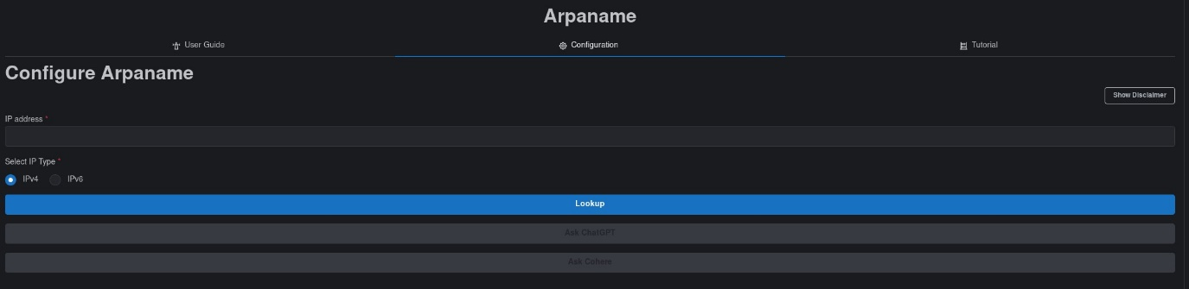
  - Step4: Results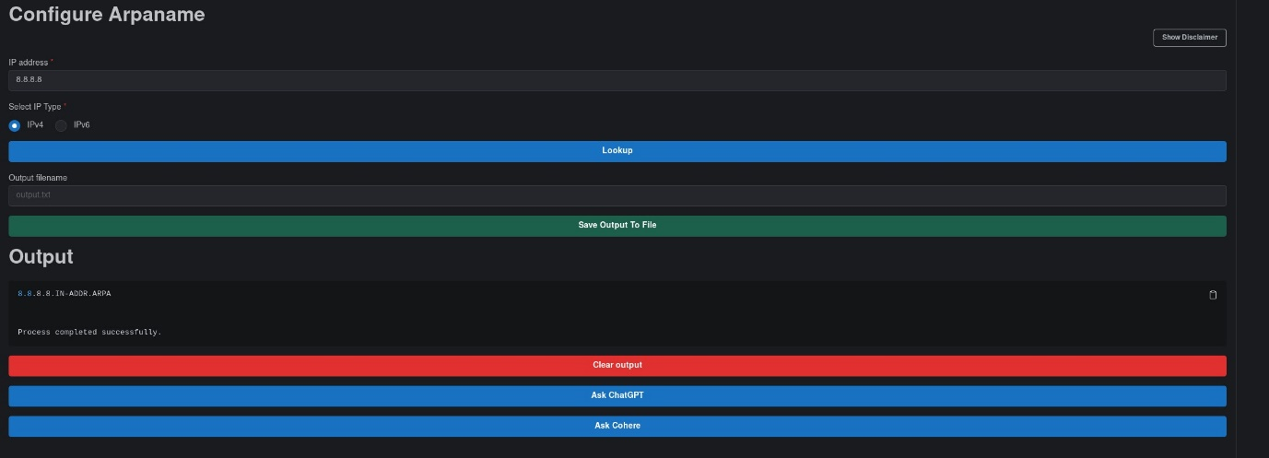
- The output panel will display the ARPA-formatted result associated with the IP address.
- A completion message confirms the lookup has finished.
- Optional actions include:
- Saving the output to a file using Save Output to File
- Copying the output using the clipboard icon
- Clearing the output to perform another lookup
Note: You can repeat step3 repeatedly for multiple addresses to be added to the output area, or you can also click the clear output if you want to clean the output field.
Output Explanation
The output confirms:
- The ARPA domain associated with the IP address.
- Successful completion of the lookup process.
A result does not guarantee that a hostname exists beyond the ARPA mapping — it simply shows how DNS represents the IP address in reverse lookup records.
Troubleshooting
- No output returned: The IP may not have a reverse DNS entry.
- Invalid IP format: Ensure the IP type (IPv4/IPv6) matches the address entered.
- Permission issues: Restart the toolkit and ensure proper execution privileges.
Learning Outcome
After completing this guide, you can:
- Perform reverse DNS lookups using Arpaname.
- Understand ARPA naming conventions.
- Use reverse DNS results to aid further reconnaissance steps.

